Neilton Clarke

Tama Art University, Tokyo

KUROKAWA, Kishō (黒川紀章) (1934–2007)

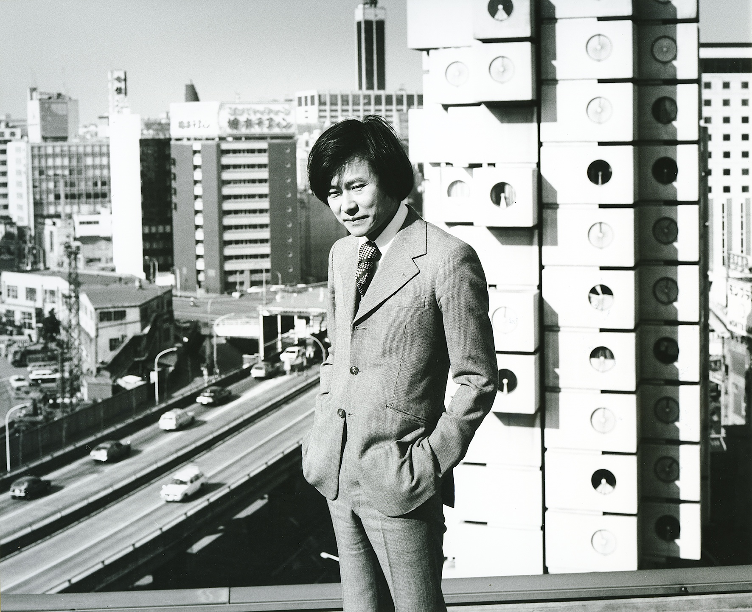

Kishō Kurokawa in front of Nakagin Capsule Tower, Tokyo (1972). Photo: Tomio Ohashi. Courtesy of KKAA, Tokyo.

Kishō Kurokawa was born 1934 in Kanie, Aichi prefecture, Japan and studied architecture at Kyoto University, graduating (B.Arch) in 1957. Further studies at the University of Tokyo under Kenzō Tange, graduating (M.Arch) from its Graduate School of Architecture in 1959, were followed by doctoral studies at the same institution until 1964. Kurokawa was a key proponent of Metabolism, the Japanese architectural movement utilising biology as a metaphoric vehicle to reconfigure the cityscape and architectural practice, coming to attention with the World Design Conference 1960 in Tokyo.

Founding his own practice, Kishō Kurokawa Architect & Associates (KKAA) in Tokyo in 1962, projects during the 1960s and 1970s were mainly across Japan and included the Resort Center Yamagata Hawaii Dreamland (1967), and highlighted as a key example of Metabolism, the Nakagin Capsule Tower, Tokyo (1972). The later 1970s saw Kurokawa pursuing engagements overseas, while the 1980s onwards consolidated such activity abroad, projects including the Japanese-German Center of Berlin (1988), Melbourne Central (1991), New Wing, Van Gogh Museum, Amsterdam (1998), and Astana International Airport, Kazakhstan (2005). Numerous awards received by Kurokawa include the Académie d’Architecture Gold Medal, France (1986), Richard Neutra Award, USA (1988), AIA Pacific Rim Award, USA (1997), Dedalo-Minosse International Prize, Malaysia (2003-4), Walpole Medal of Excellence, UK (2005), and an International Architecture Award, USA (2006). Honorary doctorates were bestowed on Kurokawa by Sofia University, Bulgaria (1988), Newport Asia Pacific University (now Anaheim University), USA (1990), Albert Einstein International Academy Foundation, USA (1990), and the Universiti Putri Malaysia (2002). Kurokawa died of heart failure in 2007.

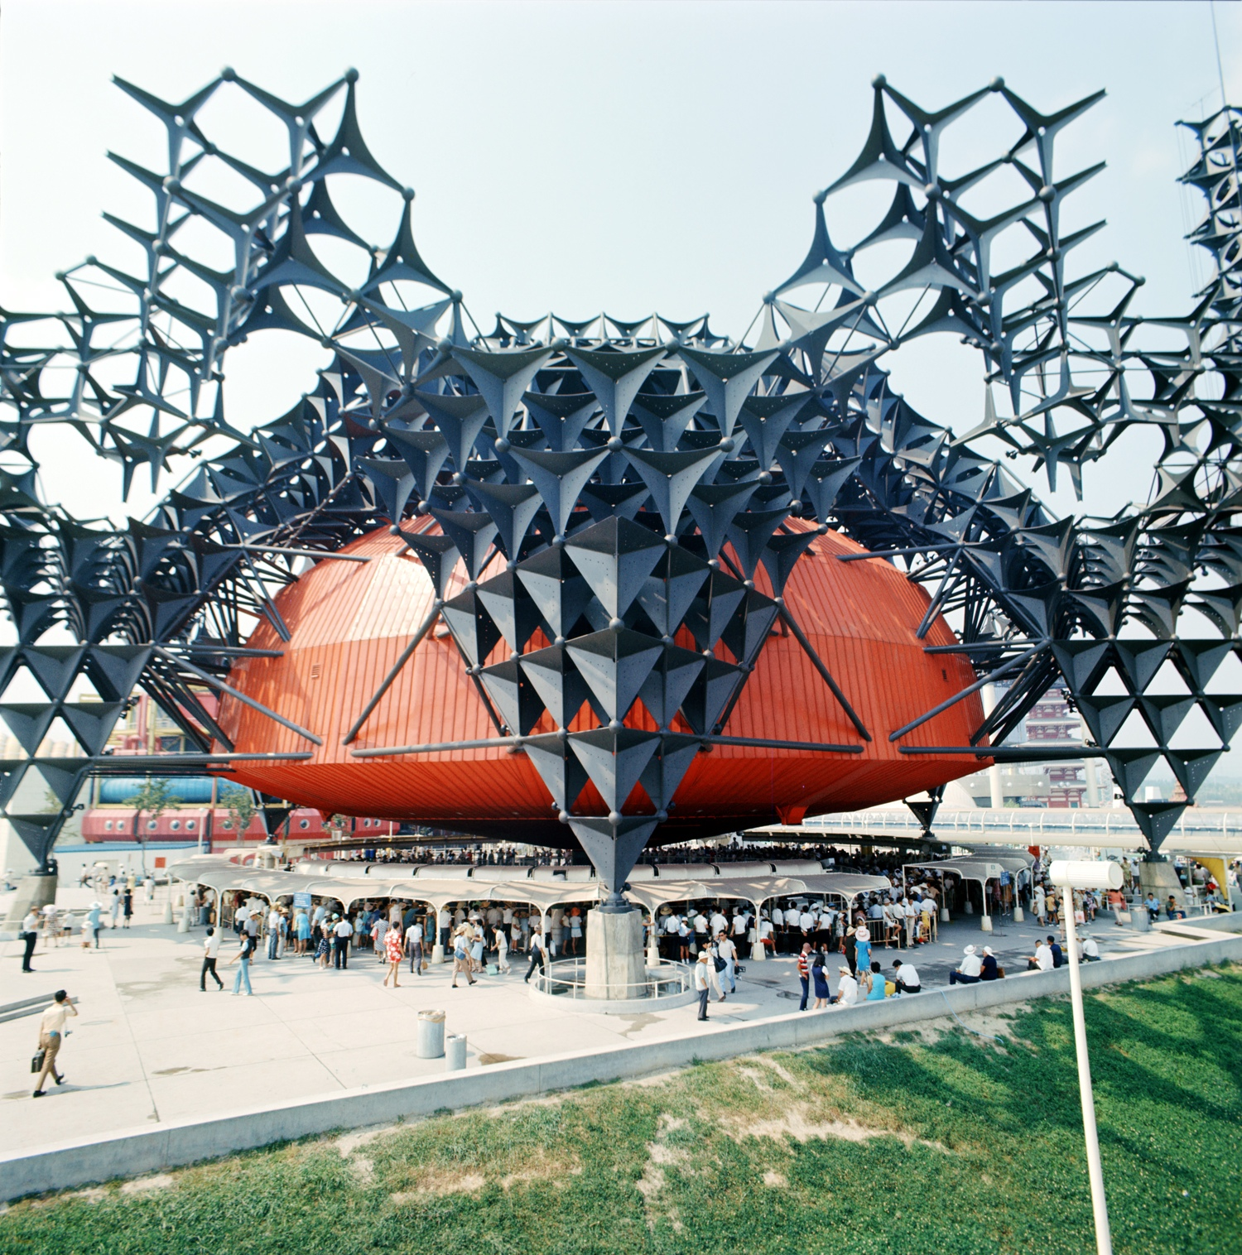

Kishō Kurokawa, Toshiba IHI Pavilion, Expo ’70, Osaka, Japan (1970). Photo: Tomio Ohashi. Courtesy of KKAA, Tokyo.

The World Design Conference 1960 in Tokyo saw Kurokawa, then in his twenties, collaborating with his Japanese peers and key foreign counterparts, and participating as a presenter propelled him into the spotlight. A number of Japanese architectural figures from Kenzō Tange’s orbit, namely Kiyonori Kikutake, Masato Otaka, Fumihiko Maki, Noboru Kawazoe, and Kurokawa, jointly published their individual essays as a manifesto and disseminated it at the event. Entitled *Metabolism: The Proposals for New Urbanism*, it included Kurokawa’s essay ‘Space City’ and posited what they saw as a need for an updated approach to architecture and urban planning – one where the built environment effectively renews itself, as living organisms do, in response to an ever-changing context through modular, extendable, and replaceable components. Kurokawa was closely involved with Metabolism from inception until its heyday, generally regarded as having occurred with Expo ’70 in Osaka and which included Kurokawa’s Toshiba IHI Pavilion, Theme Pavilion, and Takara Beautilion.

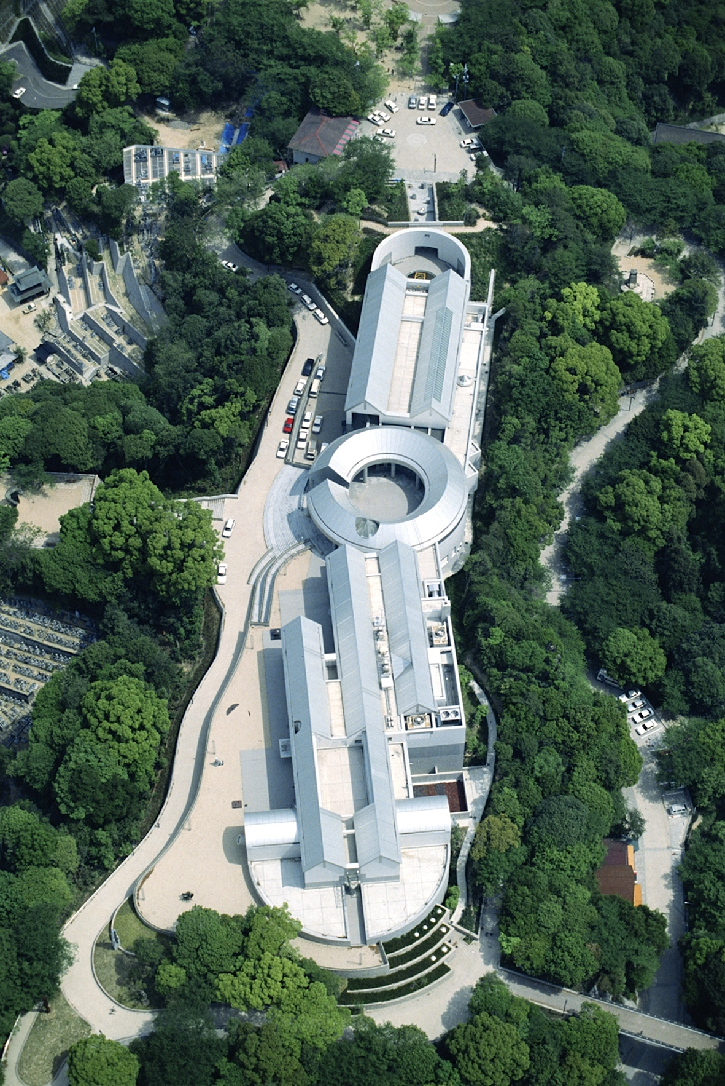

Kisho Kurokawa, Hiroshima City Museum of Contemporary Art, Japan (1989). Photo: Tomio Ohashi. Courtesy of KKAA, Tokyo.

While Kurokawa’s adoption of the architectural palette of concrete, steel, and glass may imply a rejection of tradition, particularly Japanese architectural tradition with its long history of wooden structures, Kurokawa’s work has been shown to extend such tradition and aesthetic in certain respects. Subjected to repeated earthquake and seismic activity, typhoons, tsunamis, extreme seasonal variation, and wartime destruction, Japan’s architectural evolution, being characterised by renewal and replacement, imprinted itself upon Kurokawa’s modus operandi and was carried into a new context. With materials like wood characteristically appearing unadorned in traditional Japanese contexts, fostering an expression of unmediated integrity, so too the latter-day materials, typically left exposed in their raw state. With these concepts of ‘impermanence’ and ‘materiality’, related themes upon which Kurokawa elaborated at length included ‘receptivity’, ‘detail’, and ‘sustainability’.

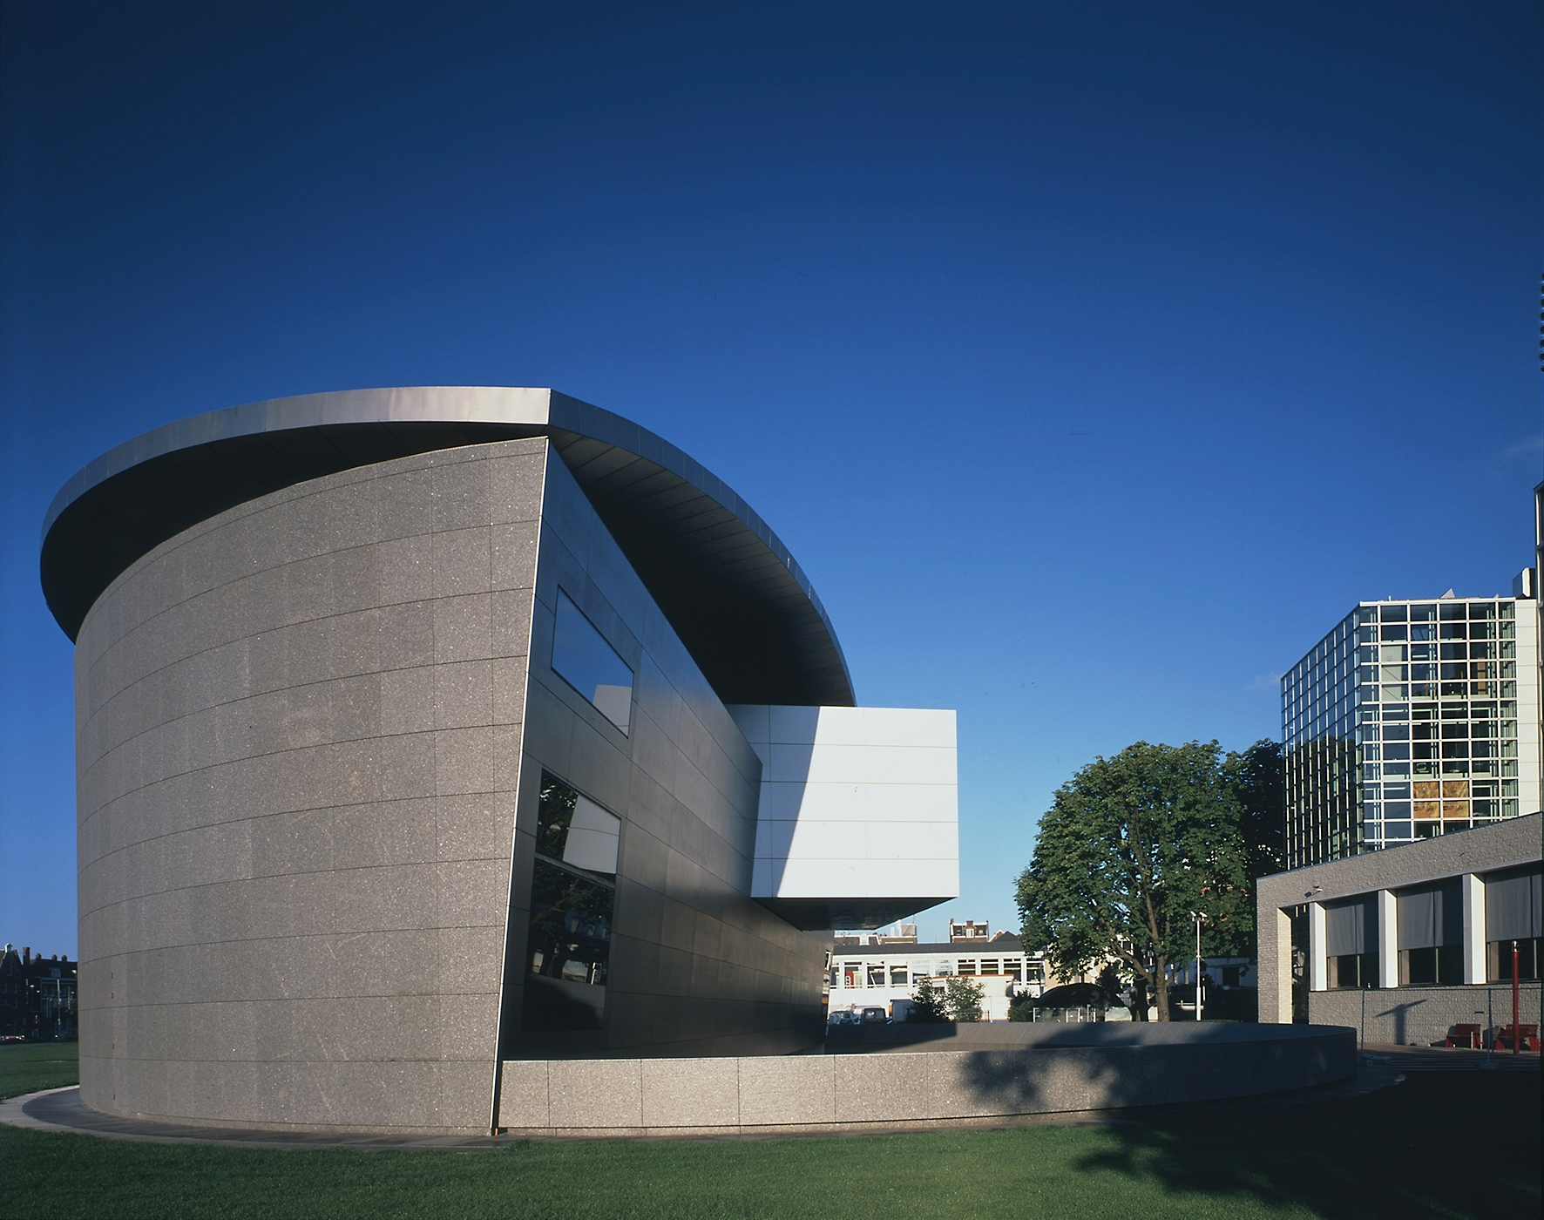

Kisho Kurokawa, New Wing, Van Gogh Museum, Amsterdam (1998). Photo: Sels Clerbout. Courtesy of KKAA, Tokyo.

Kurokawa’s evolving interest in symbiosis in the 1980s, with its focus on the integration of differences to beneficial outcomes, became increasingly reflected in his architectural work and in writings such as *Each One a Hero – The Philosophy of Symbiosis* (1997). Completion of the Kuala Lumpur International Airport (1998), requiring an edifice reflecting both the local and the global, was achieved through a synthesis of traditional Islamic and internationally modern features, aided by the inclusion of a rainforest garden to harness a sense of place.

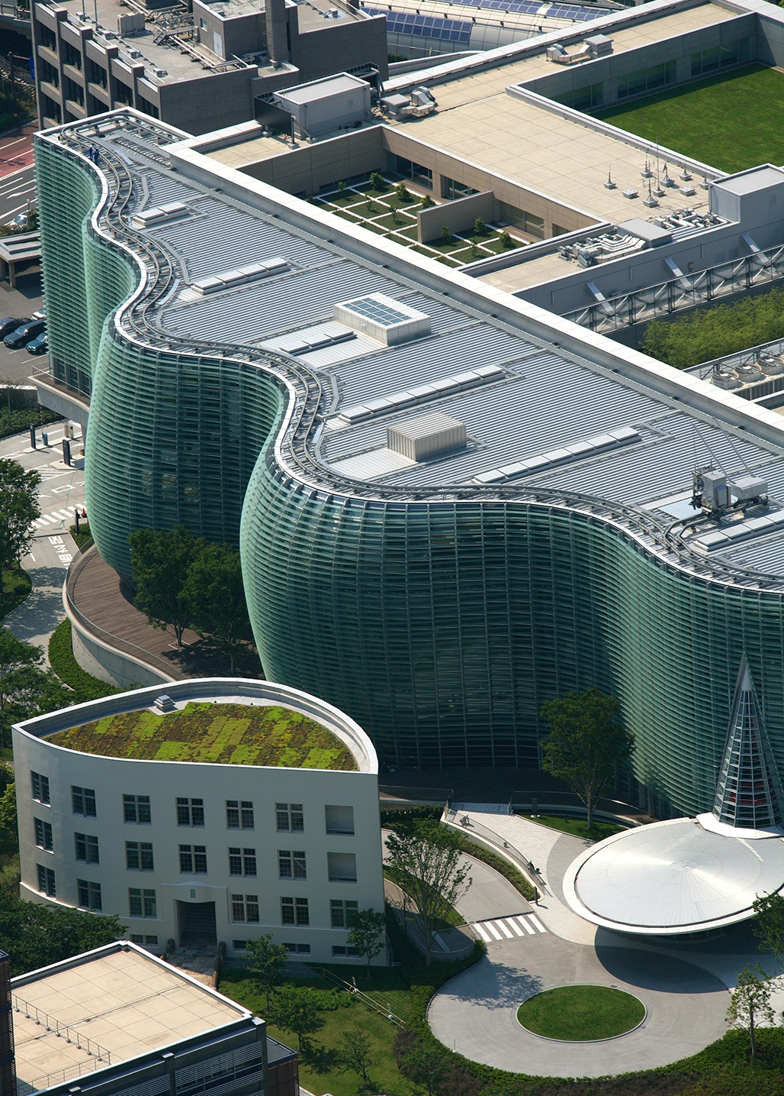

Kishō Kurokawa, National Art Center, Tokyo (2006).

Photo: Koji Kobayashi / SPIRAL. Courtesy of KKAA, Tokyo.

The National Art Center, Tokyo (NACT) (2006), an exhibiting rather than collecting institution located between the city’s Aoyama Cemetery and its urbane Roppongi area, hosts both curated exhibitions and those of the various Japanese art associations across its many cavernous spaces. The lucid articulation of space – the expansive lung-like atrium mediating between the venue’s galleries and exterior – is achieved largely through the rhythmic undulations of its all-encompassing, south-facing glass facade, lending the structure its particular respiratory demeanour while simultaneously exemplifying Kurokawa’s ideas on symbiosis.

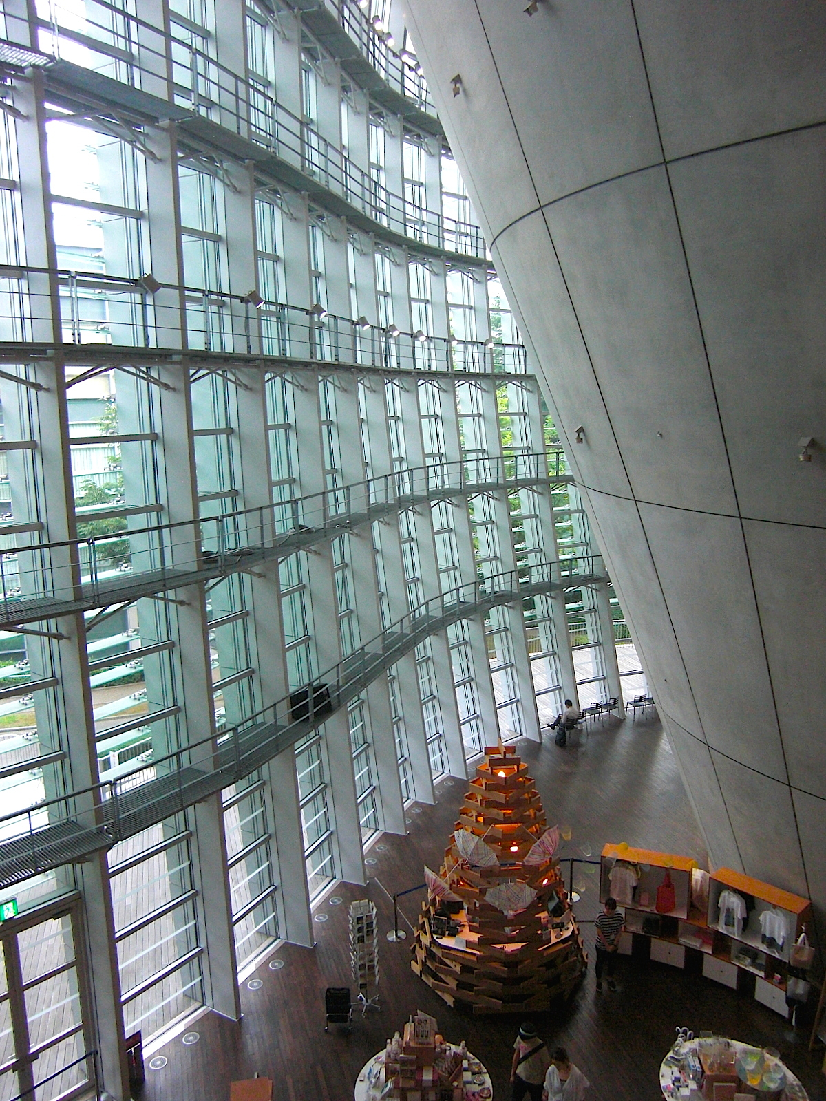

Kishō Kurokawa, National Art Center, Tokyo (2006).

Photo: Neilton Clarke

As a forward-thinking young architect whose presence began blossoming in the 1960s, Kurokawa is credited with having helped put 20th century Japanese architecture on the map. Utilising the growth of mass media in the post-war period to advantage, he was a visible presence in newspapers, magazines and on TV at that time. From 1974 Kurokawa began appearing as a regular commentator for NHK, Japan’s national broadcasting network, strengthening his own profile while importantly acting as an ambassador for architecture in a context where post-war renewal, regeneration, and development were still central concerns. Kurokawa’s multifarious activity over the course of his career encompassed the promotion of sustainable, eco-friendly architectural practices, evolving to a point where he became highly vocal about environmental matters in later years. While unelected when running as both a Tokyo gubernatorial candidate and Japanese Upper House candidate in 2007, Kurokawa initiated Kyousei Shintō (The Symbiosis New Party), with protectionist issues central to its platform. As a stakeholder and senior advisory board member of Anaheim University since 1998, the California-based institution established its Kishō Kurokawa Green Institute in his honour in 2008.

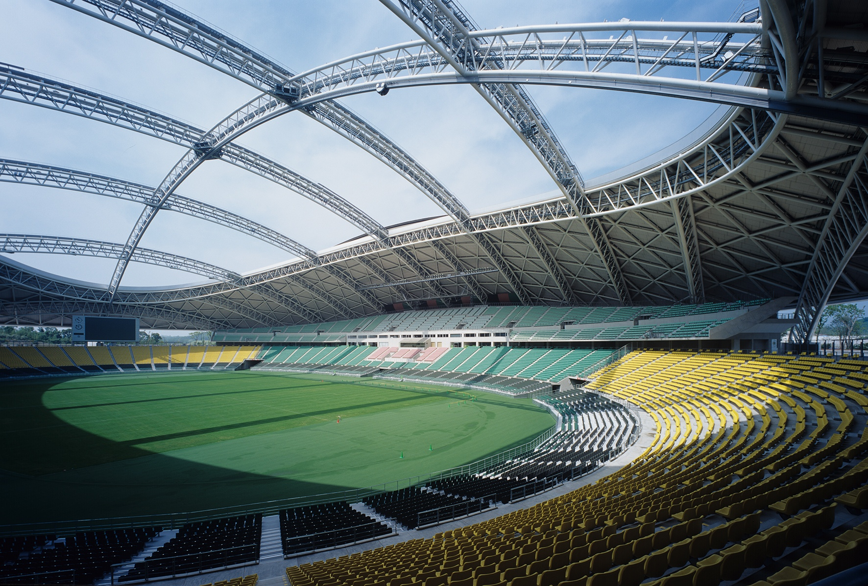

Kishō Kurokawa, Oita Stadium, Oita, Japan (2001). Photo: Koji Kobayashi / SPIRAL. Courtesy of KKAA, Tokyo.

**Other selected architectural works**

• Zhengdon New Town, Zhengzhou City, China (ongoing)

• Nagasaki Prefectural Archaeological Center, Japan (2009)

• Oita Stadium, Oita, Japan (2001)

• Toyota City Stadium, Aichi, Japan (2001)

• Osaka International Convention Center, Japan (2000)

• Kuala Lumpur International Airport, Malaysia (1998)

• Nara City Museum of Photography, Japan (1991)

• Chinese-Japanese Youth Center, Beijing, China (1990)

• Hiroshima City Museum of Contemporary Art, Japan (1989)

•  National Bunraku Theatre, Osaka, Japan (1983)

• National Museum of Ethnology, Osaka, Japan (1977)

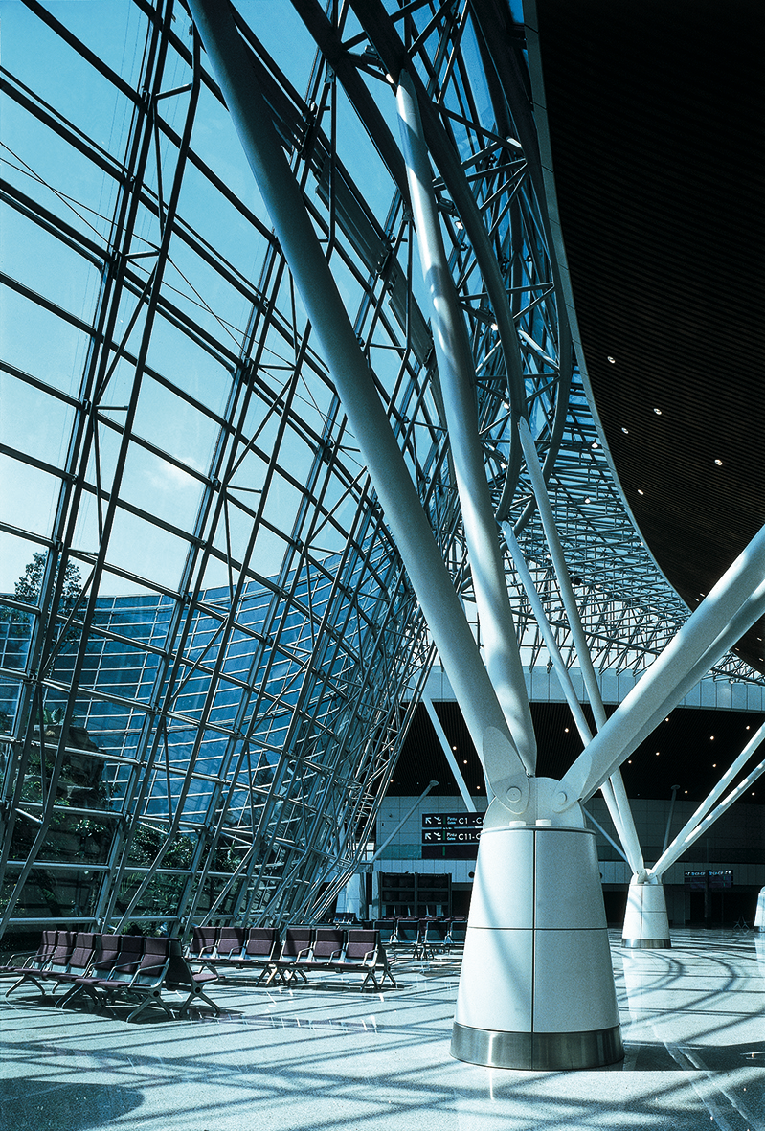

Kishō Kurokawa, Kuala Lumpur International Airport, Malaysia (1998). Photo: Tomio Ohashi. Courtesy of KKAA, Tokyo.

**Useful links**

Kishō Kurokawa homepage (includes sections on projects, writings, and other details):

[www.kisho.co.jp](http://www.kisho.co.jp)

Kishō Kurokawa discussing the National Art Center, Tokyo:

<http://www.tokyoartbeat.com/tablog/entries.en/2007/07/kisho-kurokawa-on-building-the-national-art-center.html>

Kishō Kurokawa discussing the Nakagin Capsule Building, Tokyo:

<http://www.tokyoartbeat.com/tablog/entries.en/2007/08/kisho-kurokawa-on-the-nakagin-capsule-building.html>

Rem Koolhaas presentation on Japan’s Metabolism movement, with inclusions on Kurokawa:

<http://www.japansociety.org/webcast/rem-koolhaas-on-japans-metabolism-movement>

Political Architecture – Interview with Kishō Kurokawa:

<http://www.tokyoartbeat.com/tablog/entries.en/2007/07/political-architecture-interview-with-kisho-kurokawa.html>

Metabolism – The City of the Future (Mori Art Museum exhibition, Tokyo, 2011-12, with material by and devoted to Kurokawa):

<http://www.mori.art.museum/english/contents/metabolism/index.html>

Anaheim University Kishō Kurokawa Green Institute:

<http://www.anaheim.edu/schools-and-institutes/kisho-kurokawa-green-institute>

**Further reading**

KOOLHAAS, Rem; OBRIST, Hans Ulrich (2011) *Project Japan: Metabolism Talks …* Cologne: Taschen Deutschland GmbH (ISBN: 3836525089 / 9783836525084)

NANJO, Fumio; YASUKA, Hajime; KIKUCHI, Makoto; NANGO, Yoshikazu; KATAOKA, Mami; KUROKAWA KISHO (et al.) (2011) *METABOLISM – THE CITY OF THE FUTURE* (Exhibition catalogue) Tokyo: Mori Art Museum / Shinkenchiku-sha Co., Ltd. (ISBN: 9784904700259 / English edition).

SCHMAL, Peter Cachola; FLAGGE, Ingeborg; VISSCHER, Jochen (2005) *Kisho Kurokawa: Metabolism and Symbiosis*. Berlin: Jovis Verlag GmbH (ISBN: 9783936314441)

WHYTE, Andy (2000) *MILLENIUM: Kisho Kurokawa, Architect and Associates - Selected and Current Works*.Mulgrave, Melbourne: Images Publishing (ISBN: 3936314446 / 9781864700190)

KUROKAWA, Kishō (1997) *Each One a Hero: The Philosophy of Symbiosis*. Tokyo: Kodansha International

(ISBN: 4770021402 / 9784770021403)

KUROKAWA, Kishō (1994 / 2nd edition) *The Philosophy of Symbiosis*. London: Academy Editions (ISBN: 9781854903044)

KUROKAWA, Kishō (1992) *KISHO KUROKAWA: From Metabolism to Symbiosis*. London: Academy Editions; New York: St. Martin’s Press (ISBN: 1854901192 / 0312078935)